1. For player 1: The utility of choosing X is 6(1/3) + 2(1/3) + 5(1/3) = 4.33. The utility of choosing Y is 7(1/3) + 0(1/3) + 2(1/3) = 3. Converting these payoffs into a mixed strategy, player 1 would choose X 59% of the time, and Y 41% of the time.  
     
   This mixed strategy has a utility of 3.785 for player 1.  
     
   For player 2: The utility for choosing A is 6(1/2) + 2(1/2) = 4. The utility for choosing B is 7(1/2) + 0(1/2) = 3.5. The utility for choosing C is also 4. Therefore, player 2 favors a mixed strategy with 35% chance of choosing A, a 30% chance of choosing B, and 35% chance of choosing C.

This mixed strategy has a utility of 3.85 for player 2.  
  
However, if we limit the players’ options to either (X, A) or (X, C), we can improve this utility. If player 1 is assigned X, we already determined above that X has a higher utility than Y, so player 1 prefers to stay with strategy X. If player 2 is assigned strategy A or C, both these strategies have higher utility than strategy B, so player 2 prefers to stay with the assigned strategy.

This correlated equilibrium has a utility of 6(1/2) + 5(1/2) = 5.5 for player 1, and 6(1/2) + 6(1/2) = 6 for player 2, drastically improving utility from the mixed strategy NE.

1. For the company: The utility of inspecting is -h(.5) + (v-w-h).5 = .5v - .5w – h. The utility of not inspecting is (-w).5 + (v-w).5 = .5v – w. We know that h < w, however we need to determine whether h <= 0.5w. If h is less than or equal to 0.5w, then the company would prefer not to inspect; otherwise, the company would prefer to inspect.   
     
   For the worker: The utility of shirking is (0).5 + (w).5 = .5w. The utility of working is (w-g).5 + (w-g).5 = w-g. If g is greater than .5w, the worker would prefer to shirk; if it is less, the worker would prefer to work.  
     
   If we choose to limit our choices to (inspect, work), (not-inspect, work), and (not-inspect, shirk), we can have each of these combinations occur 1/3 of the time. This makes the utility for our correlated equilibrium:  
     
   Company: (v-w-h)*(1/3) + (v-w)*(1/3) + (-w)*(1/3) = 2/3v – w – 1/3h  
   Worker: (w-g)*2/3 + (w)*1/3 = w - 2/3g  
     
   The company’s utility is improved, and depending on the values of the variables, the worker’s utility stays about the same.
2. **Prove that for a 2-player game with n strategies each, mixed NE is also correlated eq.**For a finite game (given by “n strategies), mixed NE utility = SUM ( PROD ( prob(a) * utility(a) ) ) for all a. For the same finite game, correlated equilibrium utility = SUM ( PROD ( prob(a) * utility(a) ) ) for all a suggested by the signal. The main difference between these two utility equations is the contents of “all a”. In a mixed Nash, all possible strategies are included, while in a correlated equilibrium, only signaled strategies are included. A mixed strategy Nash equilibrium is simply a correlated equilibrium that signals all strategies to be included, because in this case, “all a” becomes equal to “all a suggested by the signal”.
3. A Nash Equilibrium is if player 1 vetoes Z, its least favorite, and player 2 vetoes X, its least favorite policy. This leaves both players with policy Y, a policy they can both tolerate. Player 1 does not wish to change their veto choice, because doing so can result in their least favorite policy, Z, being the final policy left standing. Player 2 does not wish to change its veto choice for the same reason; the final policy would be their least favorite.   
     
   Additionally, the other two paths from player 1 cannot be Nash equilibria. If player 1 vetoes x or y, and player 2 vetoes the other, the outcome is Z, which is player 1’s least favorite policy, and player 1 would want to switch their original veto. If player 2 instead chose to veto Z instead of either X or Y, player 2 would be unhappy because they favor policy Z over X or Y. None of these choices can be a Nash Equilibrium.  
     
   Therefore, therefore the sole Nash Equilibrium for this game is:  
   P1 vetoes Z  
   P2 vetoes X  
   Policy Y remains

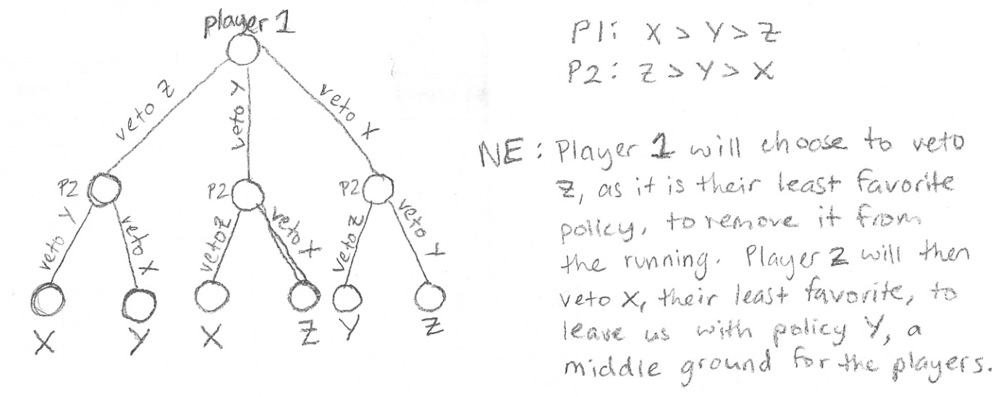

1. If the first army chooses not to attack, the payoff is (0,1).  
     
   If army 1 does decide to attack, army 2 can either choose to fight or retreat. Fighting has a payoff of -1 and retreat has a payoff of 0, making retreat the preferable option for army 2 to avoid a fight. Therefore, the subgame perfect equilibrium is for army 1 to attack and for army 2 to retreat {attack, retreat}, with a payoff of (1, 0).  
     
   If army 2 decides to burn the bridge to their mainland before the game begins, an attack by army 1 ensures that army 2 no longer has a choice and must stay and fight, which results in a payoff of (-1, -1), the worst outcome for both players. Thus, this game now consists of only one subgame. Army 1 must decide between a payoff of (-1, -1) if they attack and a payoff of (0, 1) if they do not; army 1 would obviously prefer the latter. Therefore, the subgame perfect equilibrium is now {no attack, *}, with a payoff of (0, 1), a much preferable option for army 2.  
     
   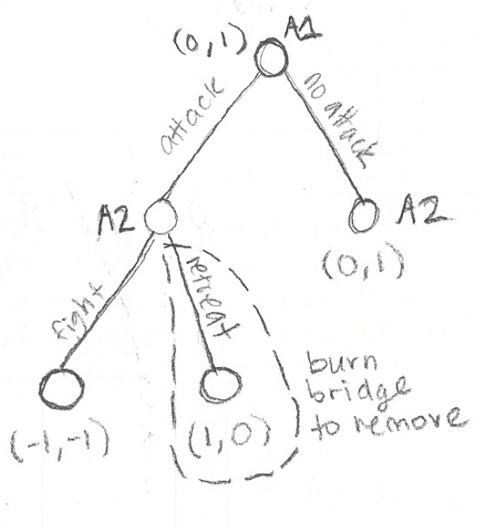
2. For each player, WIN > DRAW > LOSE. When n=4, we can see that player 1 taking 3 will inevitably lead to a draw and taking 2 will inevitably force player 2 to take 2, allowing player 2 to win. Therefore, the best outcome for player 1 (and the NE) is to force a draw by taking 3 stones. The subgame perfect equilibrium for this scenario is {take3, *}, with a payoff of (DRAW, DRAW).  
     
   When n=5, we see there is no possible way for player 1 to win, or even to force a draw. If they take 3 stones, player 2 must take 2 stones and player 2 wins. If they take 2 stones, they give player 2 the option of taking 2 or 3 stones. Since player 2 prefers a WIN to a DRAW, player 2 will take 3 stones, and once again player 2 will win. Therefore, Nash Equilibria occur in both the {take2, take3} and {take3, take2} scenarios, both of which have a payoff of (LOSE, WIN). Since there is technically a chance that player 1 taking 2 could lead to a draw, the subgame perfect equilibrium for this game is {take2, take3}, with a payoff of (LOSE, WIN).  
     
   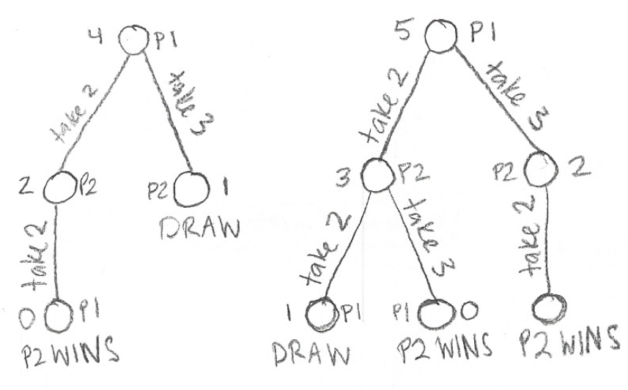
3. **Show that subgame perfect equilibrium is the same even when deleting subgames not reached in the equilibrium and assigning to the new terminal node the outcome of the deleted subgame’s equilibrium.**Take, for example, the game from question 4.The equilibrium of the subgames where player 2 must choose which policy to veto between X and Z or between Y and Z is for player 2 to veto either X or Y, leaving Z as the final policy. Therefore, we replace these subgames with a node of outcome Z, as shown below.  
     
   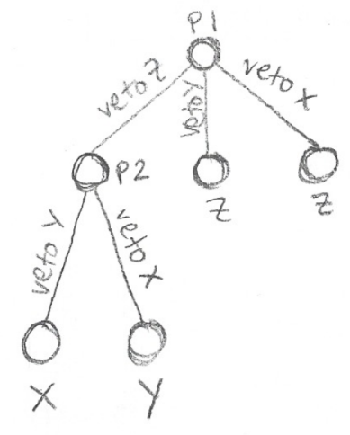  
     
   The original subgame perfect equilibrium is {vetoZ, vetoX}, and as you can see above, this equilibrium is preserved. Because the subgames reached in equilibrium plus the outcomes of the other subgames are the only elements required to determine subgame perfect equilibrium, removing these subgames and replacing them with outcome nodes completely preserves the original subgame perfect equilibrium. The payoff depends on the preferences of the players, and in this case the outcome Y is the middle choice for both players.
4. **Show that more info may hurt a player by constructing a 2-player Bayesian game with the following features:  
   Player 1 is fully informed; Player 2 is not  
   Game has unique NE in which Player 2’s payoff is higher than his payoff in the unique equilibrium of any related games in which he knows player 1’s type**

|  |  |  |
| --- | --- | --- |
|  | A | B |
| A | 2, 9 | 0, 6 |
| B | 6, 0 | 9, 8 |

State 1

|  |  |  |
| --- | --- | --- |
|  | A | B |
| A | 8, 2 | 9, 0 |
| B | 0, 9 | 2, 8 |

State 2  
  
Player 1 can be of type 1 or 2 and depending on this type we are either in state 1 or state 2.   
  
Player 1 is in fact of type 1, so we are in state 1. This means the highest payout for player 1 is in scenario {B,B} which also happens to be the second highest payout for player 2, since player 1’s type allows for mutually beneficial states. However, player 1 will undoubtedly choose B to go for their highest payout state, and player 2 does not know this.  
  
If player 2 knew which state we were in, player 2 would likely choose A to also go for its highest payout state. However, if they did so, they would end up in state {B,A}, which gives player 2 a payout of 0.  
  
However when we calculate out the utility of A and B when looking at both states together, we get (9+0+2+9)/4 = 5 for A, and (6+8+0+8)/4 = 5.5 for B. Therefore, when player 2 does not know what state we are in, player 2 will prefer choosing B over A, which gives player 2 a payout of 8 rather than the 0 it would have received had it made its choice based on a known state.